## Business Requirement Document TASL Bangalore – Spirit Purchase Order Parsing

Version: 1.0

## Objective

The objective of this software solution is to parse Purchase Order PDFs from Spirit Systems to extract specific data and then export this data into a usable format, such as an Excel or Google Sheet.

The concerned departments shall be notified for any changes in the BOM’s based on the ADM’s received on daily basis from and the updated BOM’s will be shared in CIB by weekly

## Scope:

This software will be used to:

* Parse the PDFs to extract required information, including:
  + Purchase Order No
  + PO Date
  + Deliver To/Ship To
  + Item
  + Part No
  + Part Description
  + Qty
  + Unit
  + Unit Price
  + EPR Issue
  + Drawing Issue
  + Delivery Date
* Export the extracted data into an Excel or Google Sheet for further use.

## Process followed presently:

1. Program Managers receive the PO from Spirit as an auto generated mail with the PDFs attached

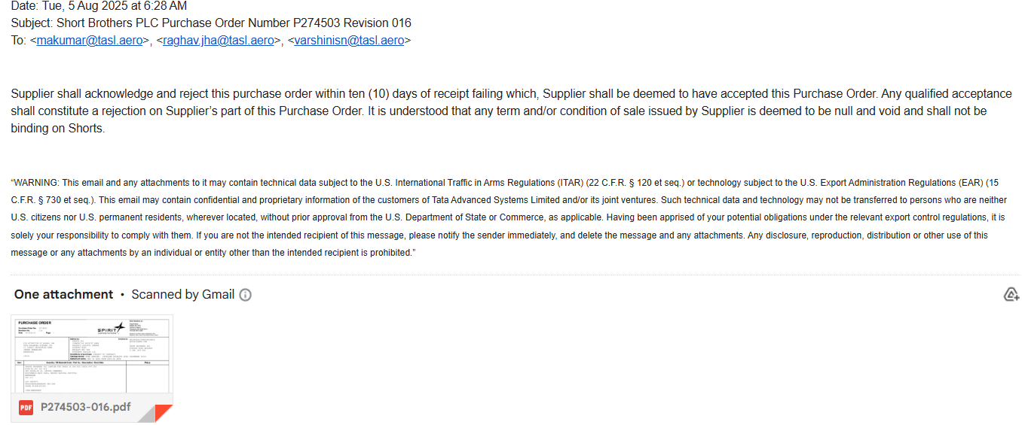

1. The PM goes through the PDF and extracts the information manually. This is done with the multiple POs received monthly
2. The PM has to respond to each of the PO within a timeframe of 7 days

## Process Required

• **Step 1:** Consolidate all Spirit Systems Purchase Order PDFs into a designated, single location.

• **Step 2:** Develop a parsing mechanism to read each PDF and extract the required data fields.

• **Step 3:** The extracted data must be structured and exported to a spreadsheet format (Excel/Google Sheets).

### Frequency Required

* **Every 7 days:** The process must be run every Tuesday.

### Man-hour Savings

* **(Please provide the number of hours saved to be added to this section.)**